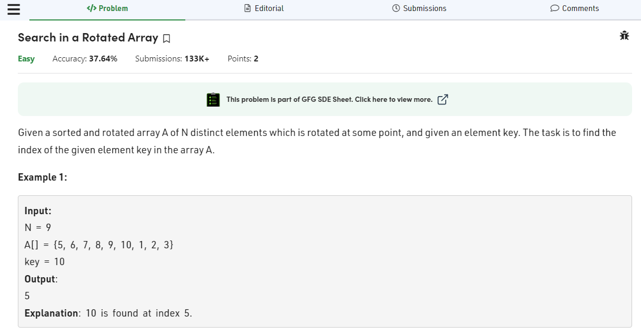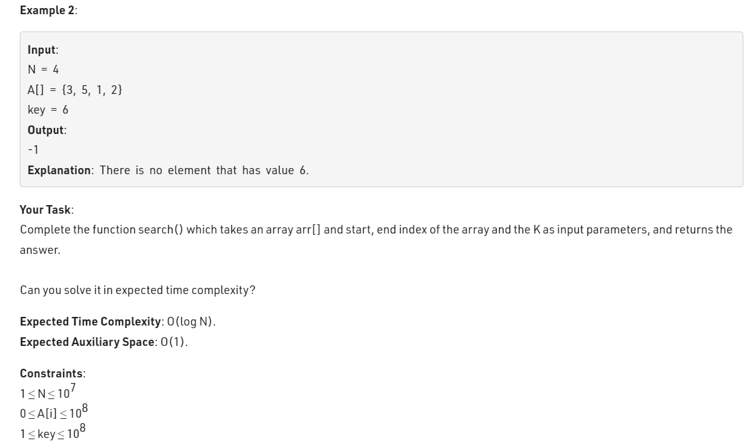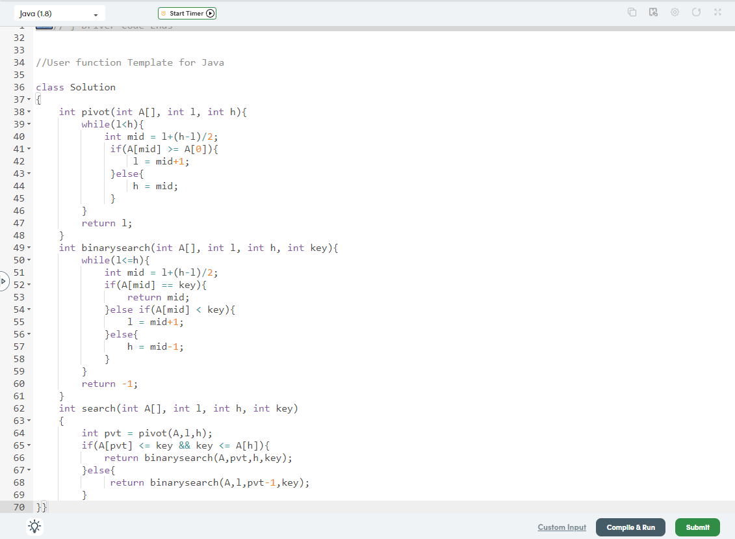

class Solution

{

int pivot(int A[], int l, int h){

while(l<h){

int mid = l+(h-l)/2;

if(A[mid] >= A[0]){

l = mid+1;

}else{

h = mid;

}

}

return l;

}

int binarysearch(int A[], int l, int h, int key){

while(l<=h){

int mid = l+(h-l)/2;

if(A[mid] == key){

return mid;

}else if(A[mid] < key){

l = mid+1;

}else{

h = mid-1;

}

}

return -1;

}

int search(int A[], int l, int h, int key)

{

int pvt = pivot(A,l,h);

if(A[pvt] <= key && key <= A[h]){

return binarysearch(A,pvt,h,key);

}else{

return binarysearch(A,l,pvt-1,key);

}

}}